**WEBSITE BÁN ĐỒNG HỒ**

|  |  |
| --- | --- |
| **GVHD: HỒ ĐẮC HƯNG** | |
| **SVTH:** | **NGUYỄN MINH QUANG - 1724801030106** |
|  | **TRẦN THANH HƯỞNG - 1724801030061** |
|  | **NGUYỄN PHƯƠNG NAM - 1724801030081** |
| **LỚP:** | **D17PM02** |

**BÌNH DƯƠNG – 12/2019**

i

**CATEGORY**

1. INTRODUCTION 1

**1.1.** **Purpose** 1

**1.2.** **Scope** 1

**1.3.** **Overview** 1

1.3.1. Topic Target 1

1.3.2. Request Of The Subject 1

**1.4.** **Reference Material** 3

**1.5.** **Definitions And Acronyms** 3

2. SYSTEM OVERVIEW 5

**2.1.** **Registration** 5

**2.2.** **Sign In** 5

**2.3.** **See Product** 6

**2.4.** **Search For Products** 6

**2.5.** **Purchase Of Products** 7

**2.6.** **View Cart** 8

3. SYSTEM ARCHITECTURE 10

**3.1.** **Architectural Design** 10

**3.2.** **Decomposition Description** 11

**3.3.** **Design Rationale** 11

4. DATA DESIGN 13

**4.1.** **Data Description** 13

4.1.1. Registration 14

4.1.2. Sign In 14

4.1.3. Generated Statistical Report 14

**4.2.** **Data Dictionary** 14

5. COMPONENT DESIGN 17

**5.1.** **Product Module** 17

**5.2.** **Online Payment Module** 17

**5.3.** **Customer Management Module** 17

**5.4.** **Online Advertising Module** 17

**5.5.** **Search Facility Module** 17

**5.6.** **Shopping Cart Module** 17

**5.7.** **New Product Module** 18

**5.8.** **Introducing Products, Services Module** 18

**5.9.** **Product Management Module** 18

6. HUMAN INTERFACE DESIGN 19

**6.1.** **Overview Of User Interface** 19

**6.2.** **Screen Images** 21

**6.3.** **Screen Objects And Actions** 24

7. REQUIREMENTS MATRIX 27

**7.1.** **Class Diagram** 27

**7.2.** **Use Case Diagram** 28

**7.3.** **Sequence Diagram** 28

8. APPENDICES 36

8.1. Picture Catalog 36

ii

iii

# 1. INTRODUCTION

## 1.1. Purpose

- The goal of this document is to provide support information on the website that sells watches (current version v1.0) . It will attempt to explain the functionality of the website and the features it provides. For that purpose one should read the user’s manual, which is written by the creators of the project.

## 1.2. Scope

* The site has a convenient and easy-to-use interface for viewing featured products, with account registration, login, logout and authorization functions for each type of user. Buy, pay online and directly, register with your Google account or your Facebook account, have chat boxes to support users, view products, search products, receive notifications when available New product for user classes.
* Function of managing, adding, deleting, editing, updating product information, orders, line items, user and staff information.

## 1.3. Overview

### 1.3.1. Topic Target

* Help us to reach potential customers.
* Helping enterprises save costs.
* Help build and promote brands.
* Helping increasing business efficiency.
* Upgraded products and adding new customers.
* Better profit.
* Help to receive feedback from customers more conveniently.
* help build credibility.

### 1.3.2. Request Of The Subject

1.3.2.1. Equipment And Software - Computers can design the web.

* Mysql database management system.
* Appserver, xampp... software design software: dreamwear, sothink, flast…

1.3.2.2. Site Requirements

* The system has 2 parts:
  + First: The customer part o Customers are those who want to buy goods, they will search
    - Necessary items from the system and order these items. So must have the following functions.
    - Display the list of items of the store for customers to see, choose and buy.
    - Customers see the news, new promotions on the site.
    - After customers choose and order directly, it must show up
    - purchase order so customers can enter purchase information and view invoices purchase.
  + Second: For administrators o The owner of the application has control over all activities of the system. This user is given a username and password to login the system to perform its function.
    - Function update, edit, delete items, type of goods, manufacturer.
    - Receive customer orders check. Show orders. o Statistics by day, time period.

## 1.4. Reference Material

- The official website of the project contains a brief description of the project, screenshots, links, tutorials and of course it gives users the ability to download and contribute to the project in different ways, since it is an open source project.

https://cybersoft.edu.vn

## 1.5. Definitions And Acronyms

* QLACT: Detailed Photo Management ▪ ktc: Check the Chain.
  + Idact: Detailed Photo Id.
  + ktsp: Product Inspection.
  + ktact: Checking Detailed Photos.
  + actsua: Detailed Photos Edit.
* QLGH: Shopping Cart Management
  + lstgh_qlgh: Shopping Cart Management Shopping Cart.
  + ghx: Cart Clear.
  + nglichsu: User history.
  + splichsu: Product History.
  + adlichsu: Admin History.
* QLLS: Managing History
  + lstnd: Content List.
* Production management: Production Management ▪ lstnsx: Manufacturer List.
  + ktnsx: Check the Manufacturer.
  + lstasp: Product Photo Lis.t ▪ lstsp: Product List.
  + lstgh: List Cart.
  + lstqlnsx: List of Manufacturer Management.
* QLSLIDE: Slide Management
  + - lstslide: List Slide.
    - Idsl: ID Slide.
    - ktsl: Check Slide.
* QLSP: Product Management ▪ lstsp: Product List.
  + - Idsp: Product ID.
    - sp: Products.
* AdminConTroller
  + - ktslsp: Check Product Quantity.
    - sl: Quantity.
    - kttk: Check Account.
    - qlndx: Manage Content View.
    - lstqlnd: Content Management List.
* Login
  + - fb: FaceBook.
    - mahoamatkhau: Password Encryption.
    - timkiemtaikhoan: Search Account.

# 2. SYSTEM OVERVIEW

## 2.1. Registration

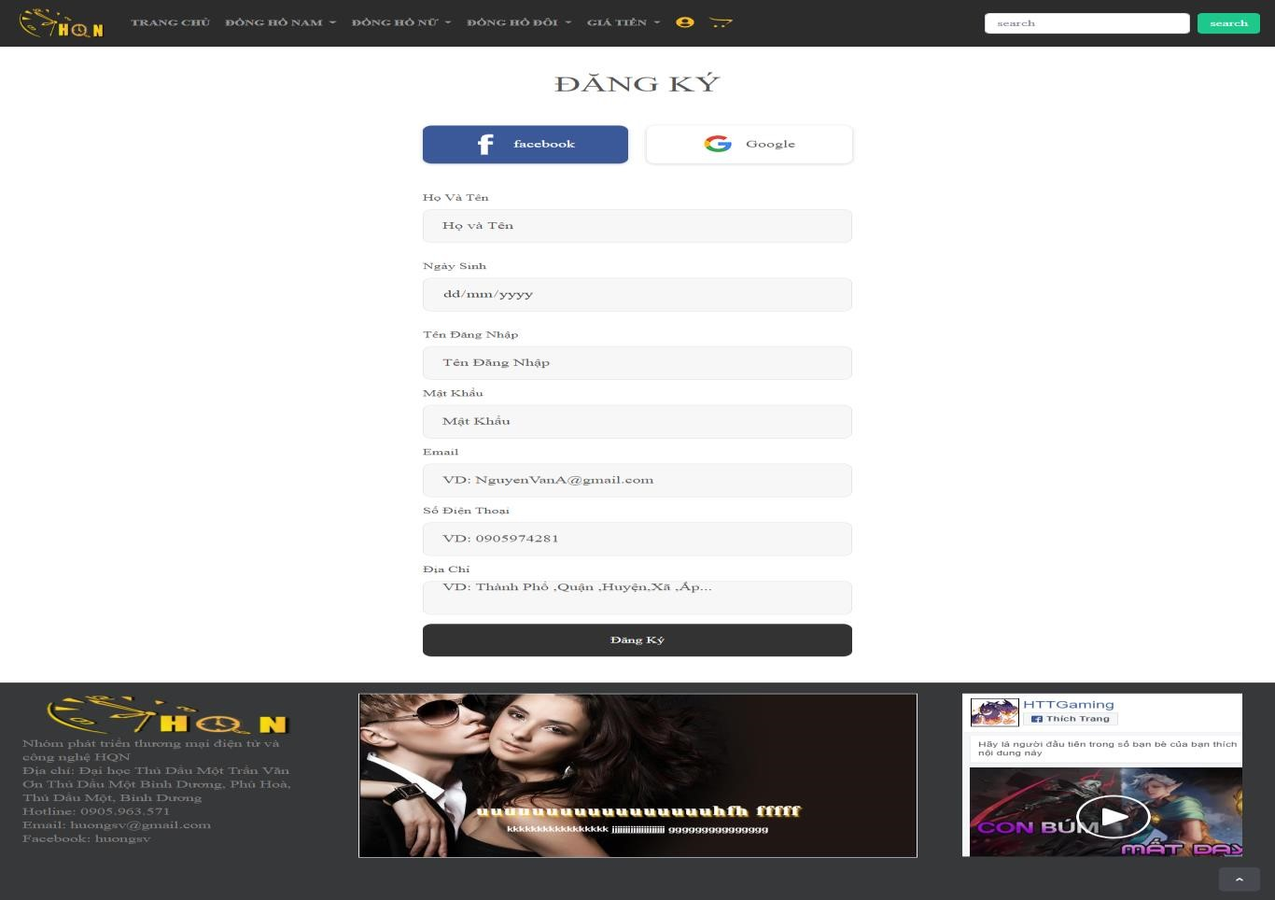

Figure 2.1 Registration

## 2.2. Sign In

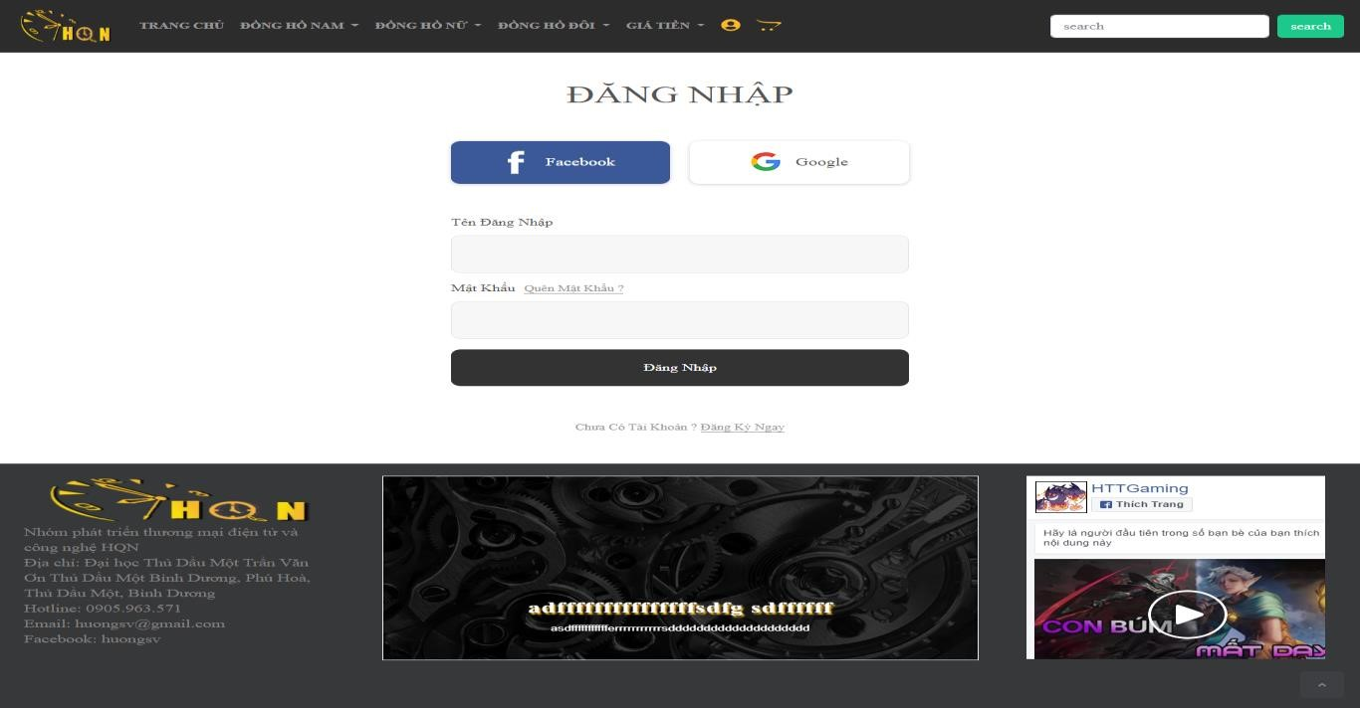

Figure 2.2 Sign In

## 2.3. See Product

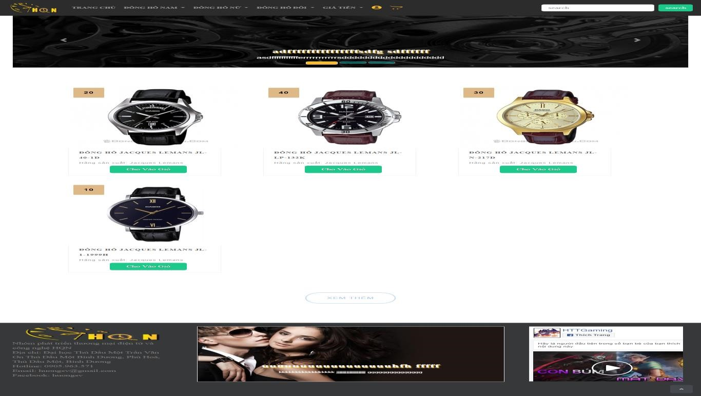

Figure 2.3 See Product

## 2.4. Search For Products

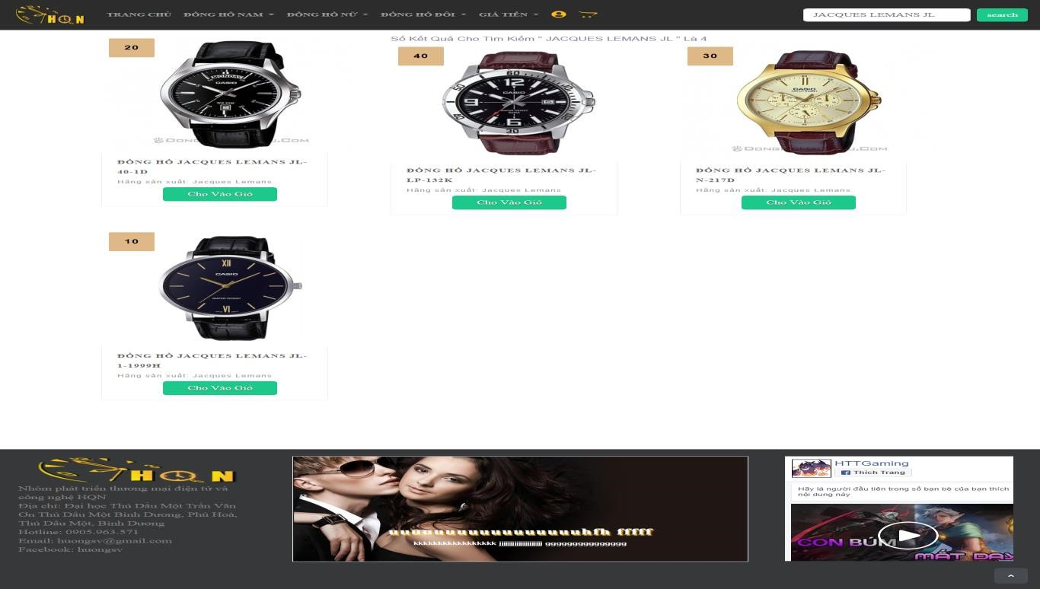

Figure 2.4 Search For Products

## 2.5. Purchase Of Products

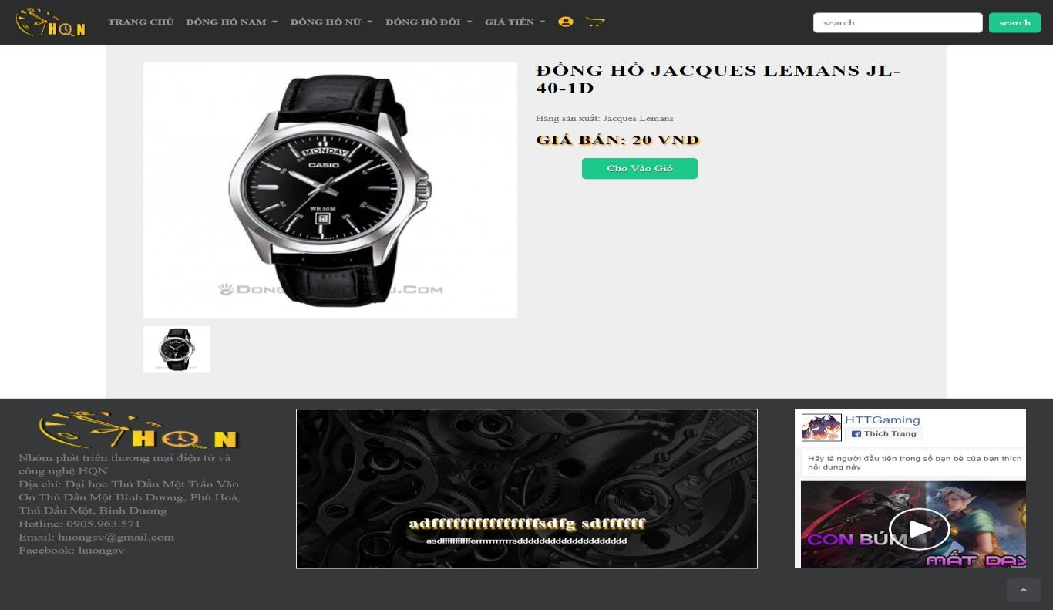

Figure 2.5 Purchase Of Products

## 2.6. View Cart

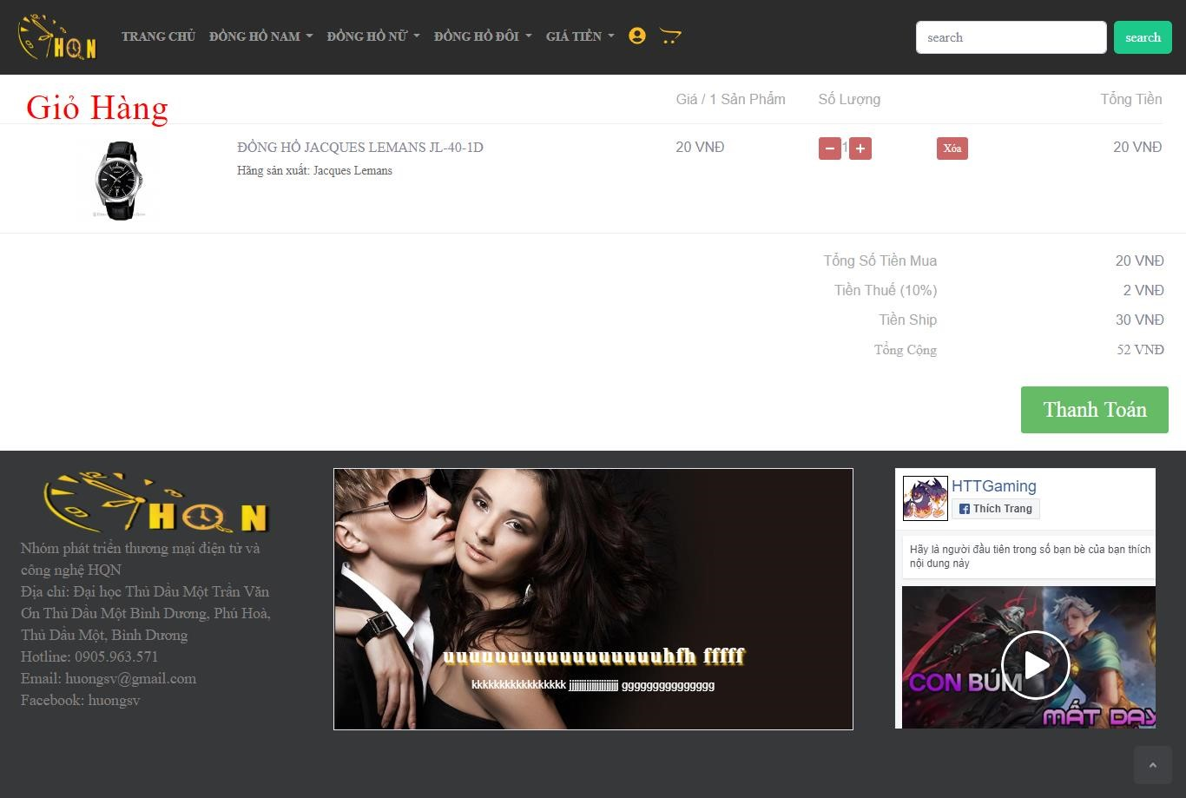

Figure 2.6 View Cart

#### 2.7. Layout - Admin

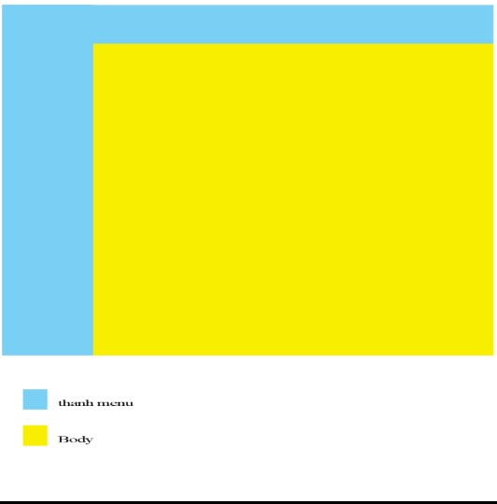

Figure 2.7 Layout admin

#### - User

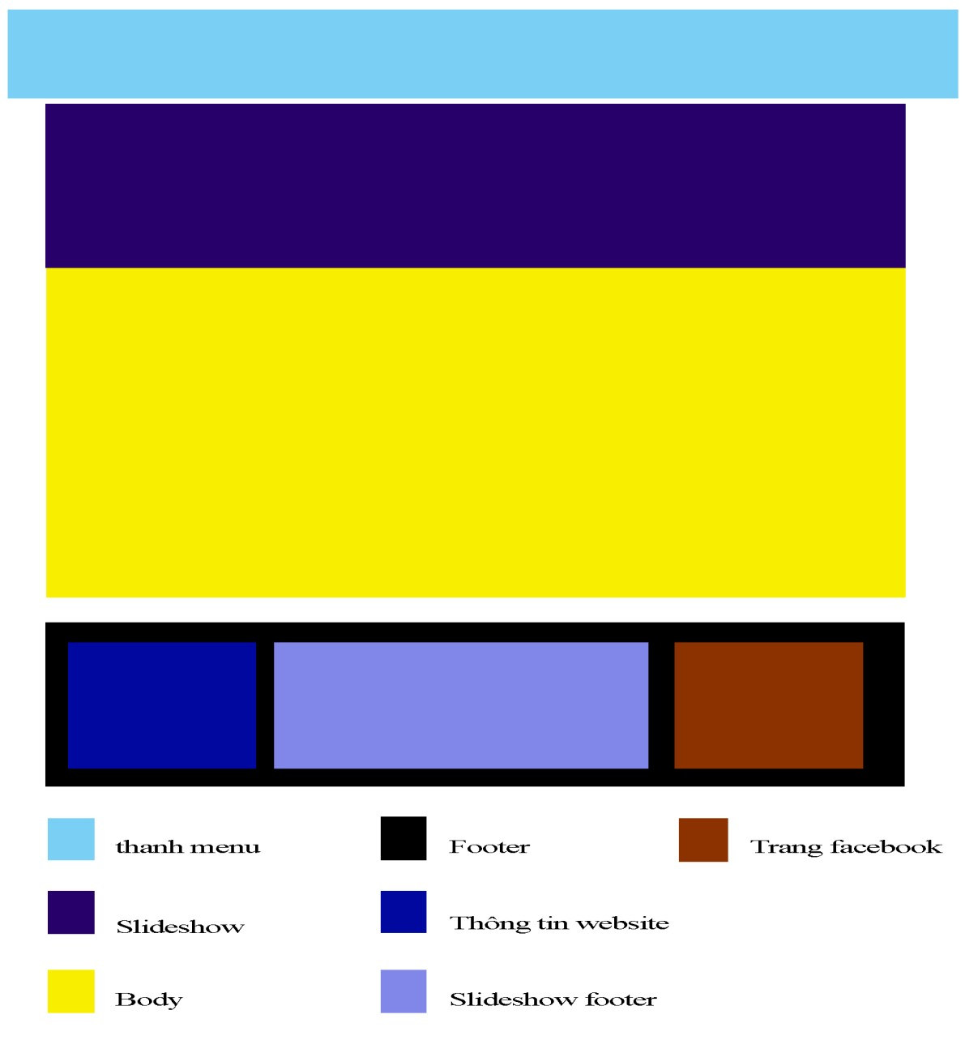

# 3. SYSTEM ARCHITECTURE

## 3.1. Architectural Design

* Architectural design is a concept that focuses on components or elements of a structure. An architect is generally the one in charge of the architectural design. They work with space and elements to create a coherent and functional structure.
* There are several steps involved in the design process for an architectural project. Each step is very important to the overall look, feel, and safety of the project. The steps are as follows:
  + Schematic Design o The first step of the design phase is the schematic design. The schematic design is where the architect gathers information on the needs, style, and wants for the project and from there the he will create two to three design options for the client to review.
  + Design Development o In the design development, the architect will take the schematic designs and develop them to an approved design concept. Any changes the client wants to make to the design should be communicated to the architect during this phase.
  + Construction Documents o Construction documents are given to a contractor for the construction of your project. An architect will put together drawings with a lot of detail on them for the contractors to follow when building.
  + Bidding

o Bidding is when the architect or client seeks a contractor for their project. They bid the job to the contractor by giving them bid documents which display details of the project. These documents include construction documents and technical specifications.

* + Construction o Construction begins once you’ve found a contractor you like, and you’ve settled on a design concept that fits your needs. Your architect will be in contact with your contractor throughout the duration of the construction phase to ensure that your project is being built according to the plans.

## 3.2. Decomposition Description

- This section describes the decomposition of the system design in three different ways.

* Firstly, the design is decomposed by grouping data and functions into cohesive modules.The module decomposition identifies each of the modules and briefly outlines their purpose, type, functions, and list of sub modules constituting this module.
* Next, we look at the design from the point of view of concurrent processes/threads that run. We identify each thread of execution in the program design and outlines the details of the processes just as for the modules in the previous section.
* Finally, we identify the data entities in the design and briefly describe their purpose.

## 3.3. Design Rationale

* Your client is on the internet.
* Sales all the time, everywhere.
* Implement effective marketing strategies.
* Increase prestige and brand value.
* Reduce business costs.
* Most convenient for customers.
* To introduce products and services professionally.
* Customer service is better.
* Increase the accessibility of – customers to potential customers.
* Unlimited ads.
* Our benefits - Business 24 months days.
* Building – brand development.

# 4. DATA DESIGN

## 4.1. Data Description

* A website selling watches will post the latest and prominent watches for customers, the website also manages the regular upload of the latest watch models and promotional items on the website. The following is the data description of the website:
* A website consists of many pages, each of which has its own theme and function. Each Topic must have a link to each page, with the name and topic, and content of each page. The homepage will summarize the content of the entire website including the latest watch models, a summary of each topic, promotional items and manufacturer's information. The topic page will post news of that topic. And login page to buy products. Working site of customers and admin.
* Each topic must be different and distinguishable from other topics. The administrator will manage the number of available topics on the website and the name of each topic. Each topic will have a keyword to identify the topic. Each topic will have separate interface for each topic and suitable for that topic.
* Advertising items will be managed by the administrator, each advertising item must be distinguished from each other. The website administrator will manage the number of ads in the website. The ad management so that the administrator can know the ad content, the link on the ads, the date of the ad and the number of readers clicking on the ad.
* Each customer must provide their personal information as well as their address and phone and email. Each customer will have an account to distinguish them from each other.
* The administrator will store the number of times and the date that customers log in, log out, purchase, and order times.

### 4.1.1. Registration

- Each customer must register personal information including: full name, date of birth, address, email, phone number, username, login password.

### 4.1.2. Sign In

* Customers must login to purchase products including: username, password login.
* Admin must log in to manage accounts added, delete corrected products.

### 4.1.3. Generated Statistical Report

- Statistics on customer situation for website

* How many customers are coming to the website for a day?
* What' s the most hàngxem?
* Customer clicks?

## 4.2. Data Dictionary

* Product Table

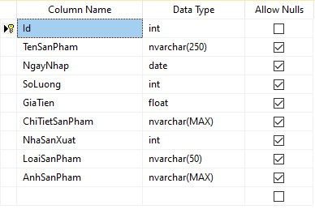

Figure 4.1 Product Table

* Account Table

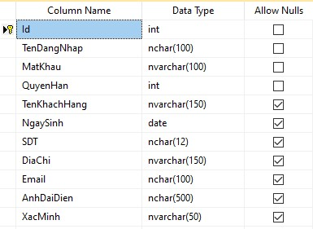

Figure 4.2 Account Table

* Manufacturer Table

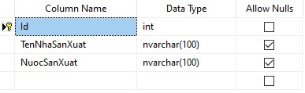

Figure 4.3 Manufacturer Table

* Payment Table

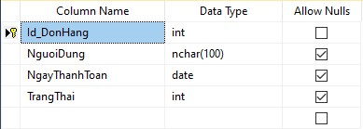

Figure 4.4 Payment Table

* Cart Table

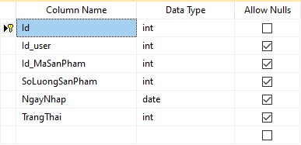

Figure 4.5 Cart Table

* Delivery Schedule Table

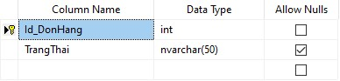

Figure 4.6 Delivery Schedule Table

5: Component Design

# 5. COMPONENT DESIGN

## 5.1. Product Module

* In this module, you can share your products with a product group in certain groups criteria, create a convenience for viewers searching for products.
* Present detailed information, images and prices of products that make it easy for customers to compare, choose between products.

## 5.2. Online Payment Module

* A website that can' t afford to be functional. Network payments are a form of payment that is becoming popular now due to the strong development of e - commerce.
* Network payments help customers more convenient in shopping, thereby stimulating customer procurement.

## 5.3. Customer Management Module

- Keeping information on customers, the order of order, purchase and purchase of invoices, payment invoices or responses of the hàng… to be easily controlled by the enterprise, customer service, quality of goods and product quality.

## 5.4. Online Advertising Module

- This module gives you promotions, special company events to track customers.

## 5.5. Search Facility Module

- This module will directly affect the user experience and the customer attraction. Their customers are always looking for product information the fastest way without making too much progress and taking time. Help them find all the information on the website with relevant keywords.

## 5.6. Shopping Cart Module

5: Component Design

- The module includes shopping cart functions, orders, customer management to make it easy for customers to choose goods, subscribe to order or add products. This module should integrate online payments on the website.

## 5.7. New Product Module

- Your website can' t be missing this module for the purpose of updating products, new businesses. It will help your customers pay attention to you.

## 5.8. Introducing Products, Services Module

* Any sales website that needs to have this module to show customers specific information about what the product you're offering is? Information about features, origins, product prices, and non - visual.
* The display of products should be divided by category, each category will have many products within and are presented as the most convenient list for customer tracking.

## 5.9. Product Management Module

- The module will support you in updating, editing, adding, or removing products, services. This module needs to be optimized for the admin.

# 6. HUMAN INTERFACE DESIGN

## 6.1. Overview Of User Interface

* Home Page

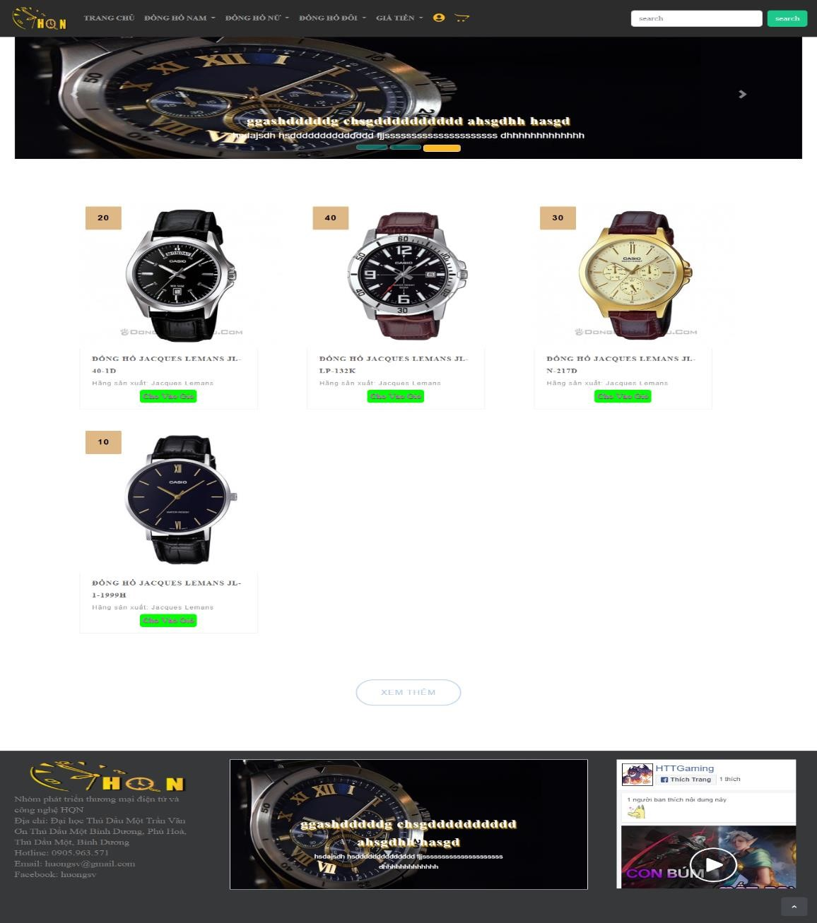

Figure 6.1 Home Page

* Men's Watch

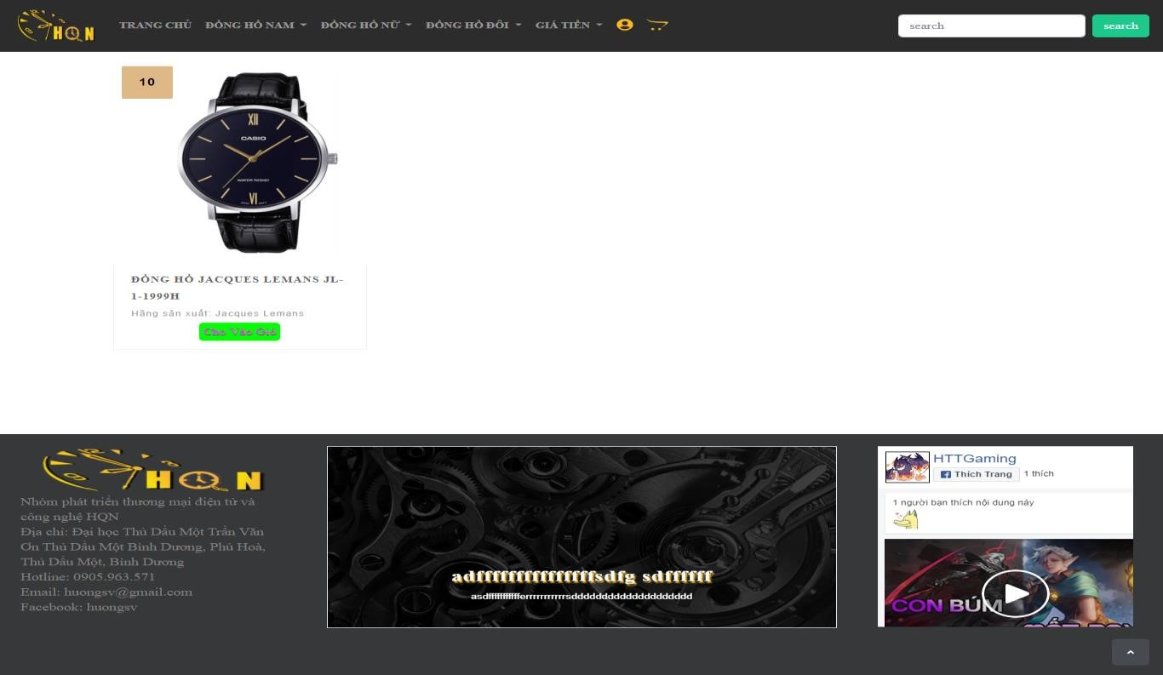

Figure 6.2 Men's Watch

* Women's Watches

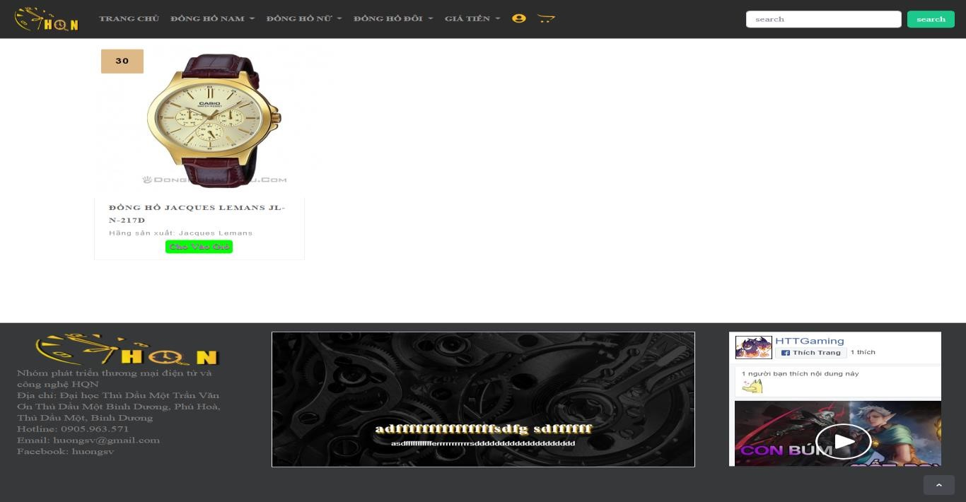

Figure 6.3 Women's Watches

* Couple Watches

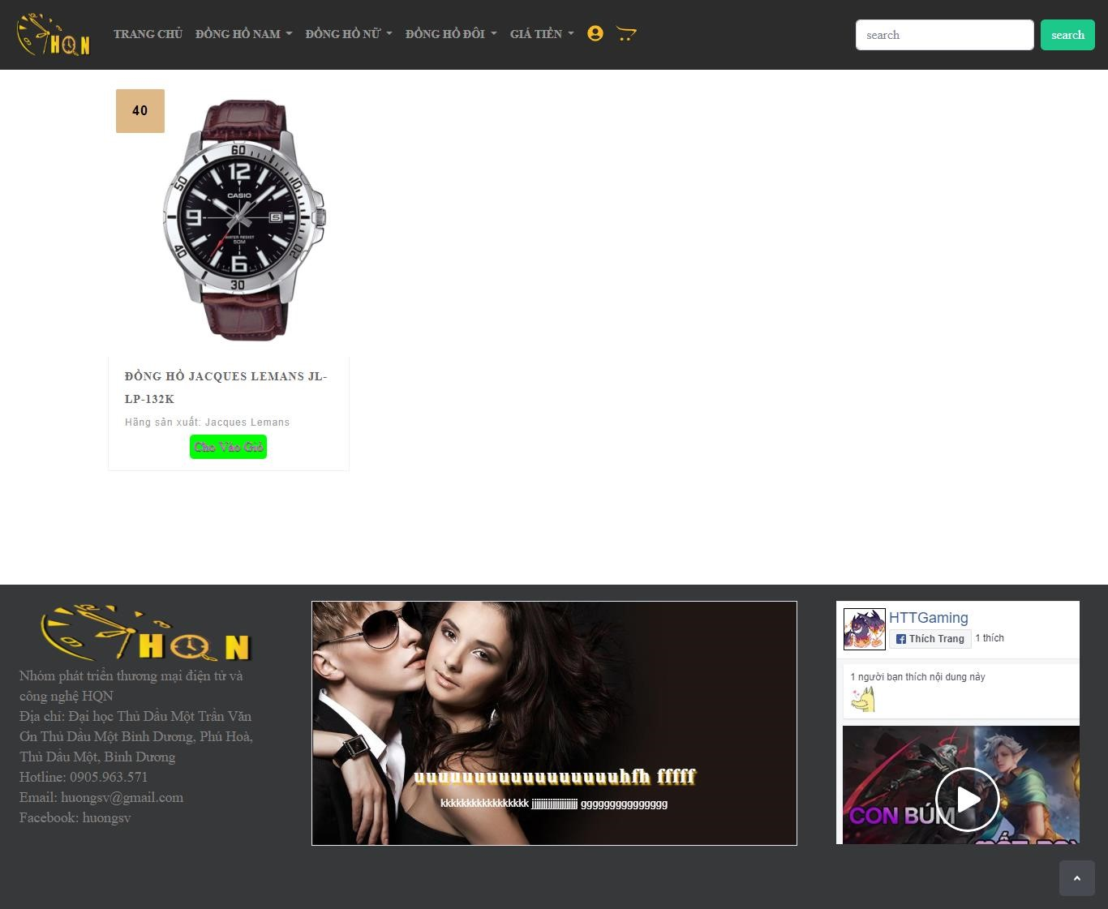

Figure 6.4 Couple Watches

## 6.2. Screen Images

- Admin:

* Product Information

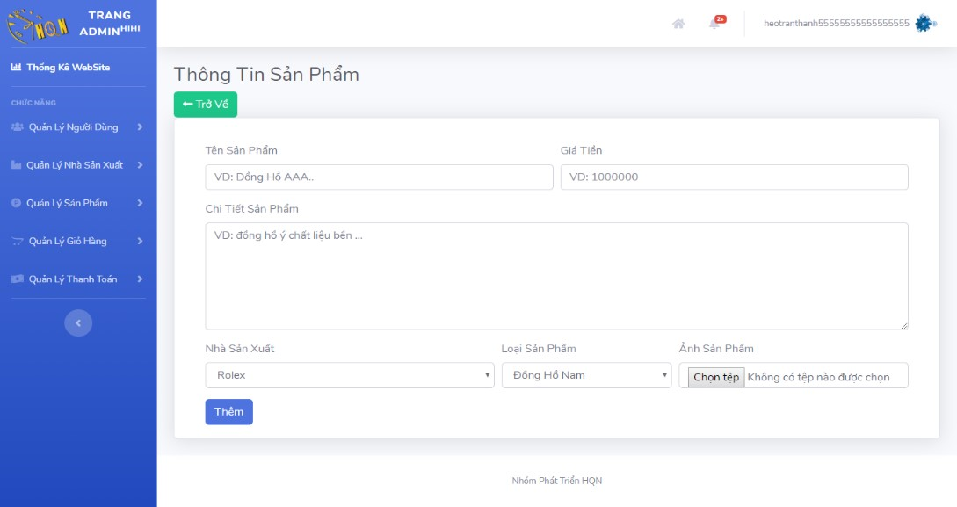

Figure 6.5 Product Information

* Manufacturer Information

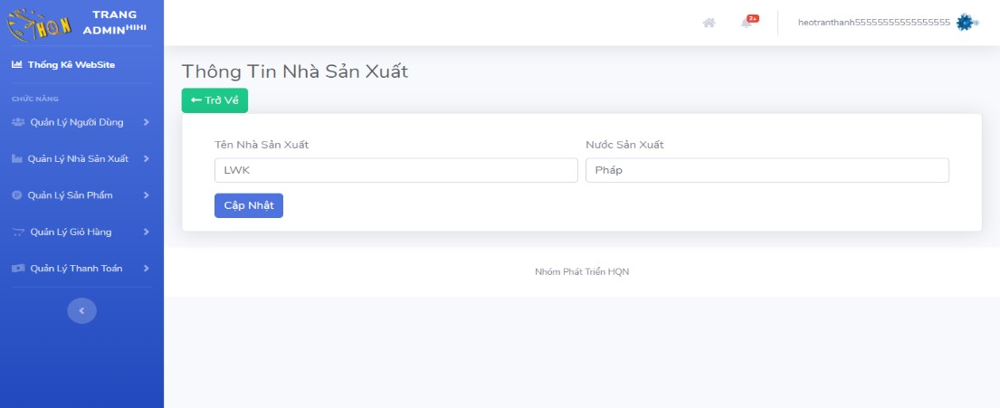

Figure 6.6 Manufacturer Information

* User Management

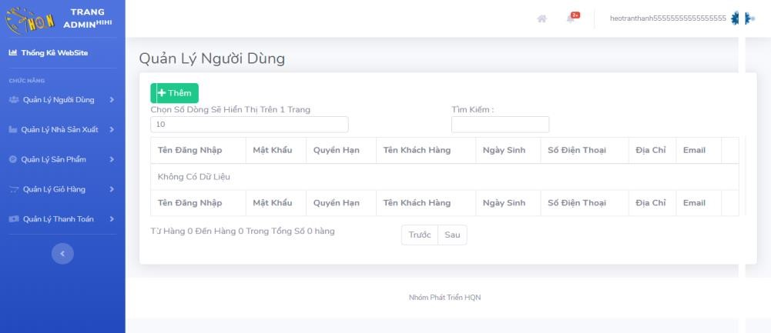

Figure 6.7 User Management

* Product Management

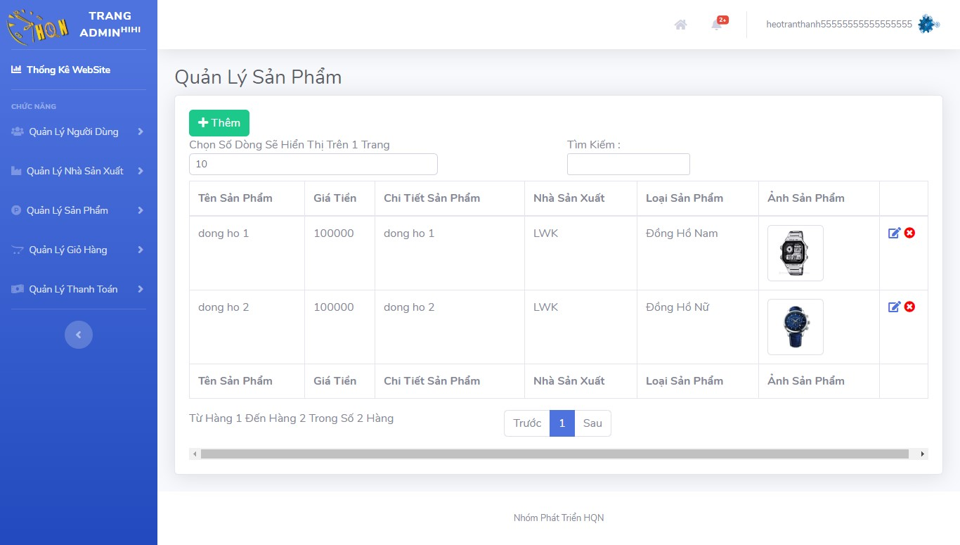

Figure 6.8 Product Management

* Product Information

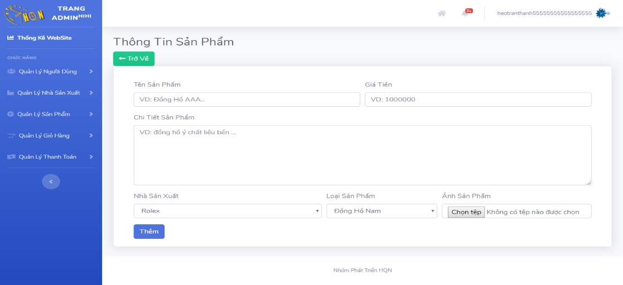

Figure 6.9 Product Information

* Cart Information

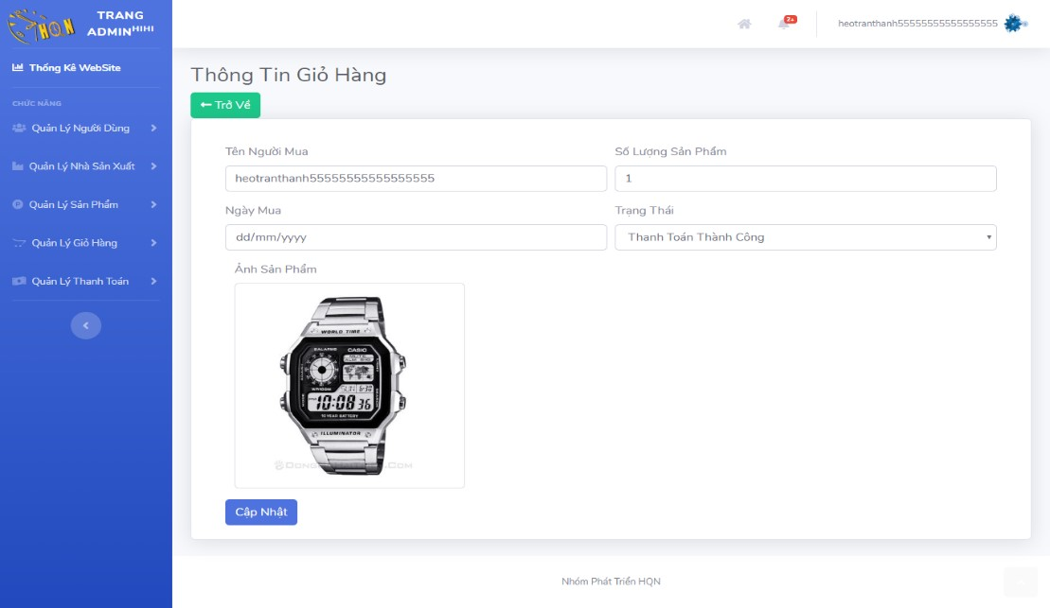

Figure 6.10 Cart Information

* Manage Cart

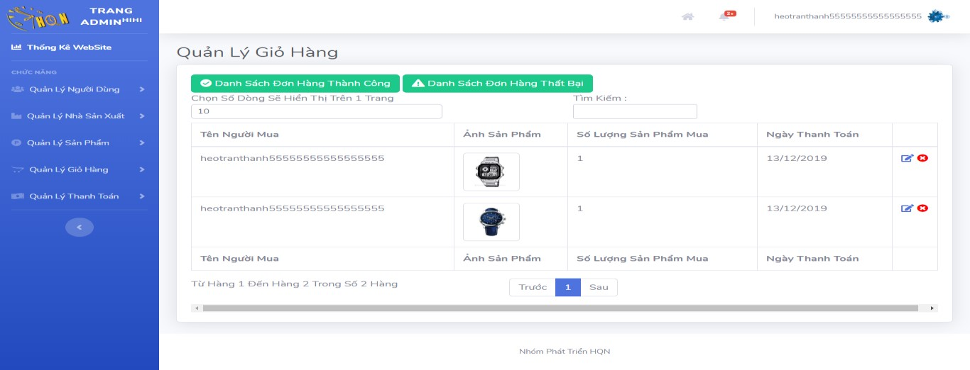

Figure 6.11 Manage Cart

## 6.3. Screen Objects And Actions

* Function block diagram CHOOSE AND ORDER

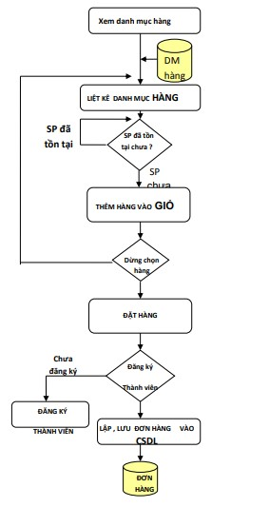

Figure 6.12 Function block diagram choose and order

* Function block diagram PAYMENT

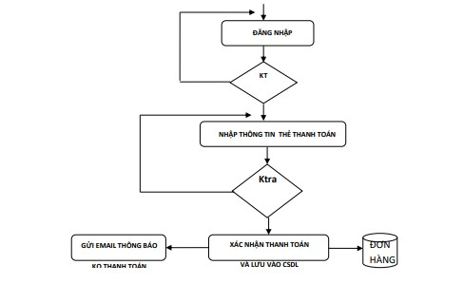

Figure 6.13 Function block diagram payment

* Function block diagram REGISTER MEMBERS

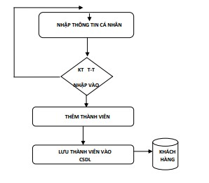

Figure 6.14 Function block diagram register members

* Diagram of the SEARCH function block

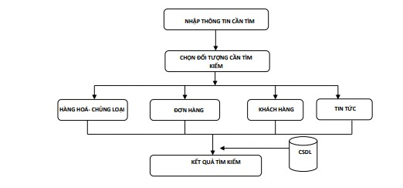

Figure 6.15 Diagram of the search function block

# 7. REQUIREMENTS MATRIX

## 7.1. Class Diagram

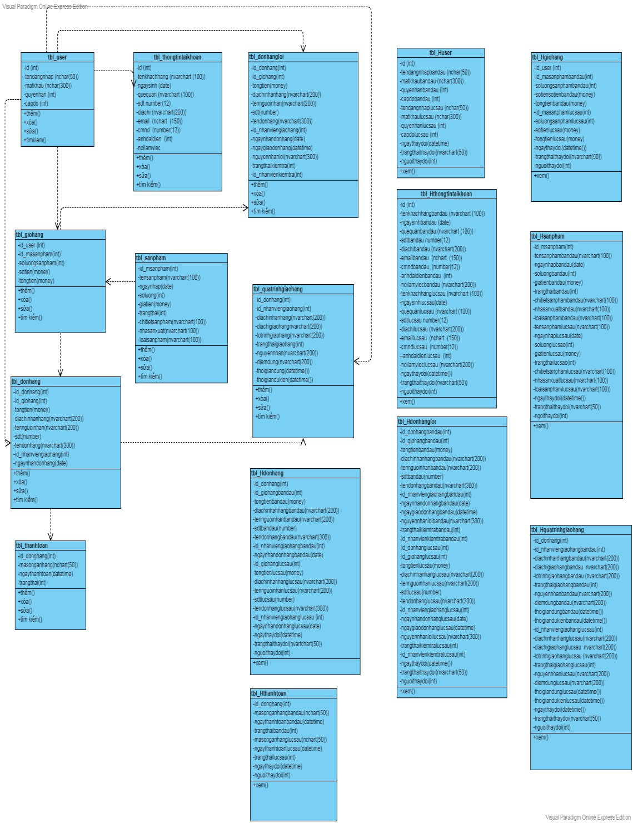

Figure 7.1 Class Diagram

## 7.2. Use Case Diagram

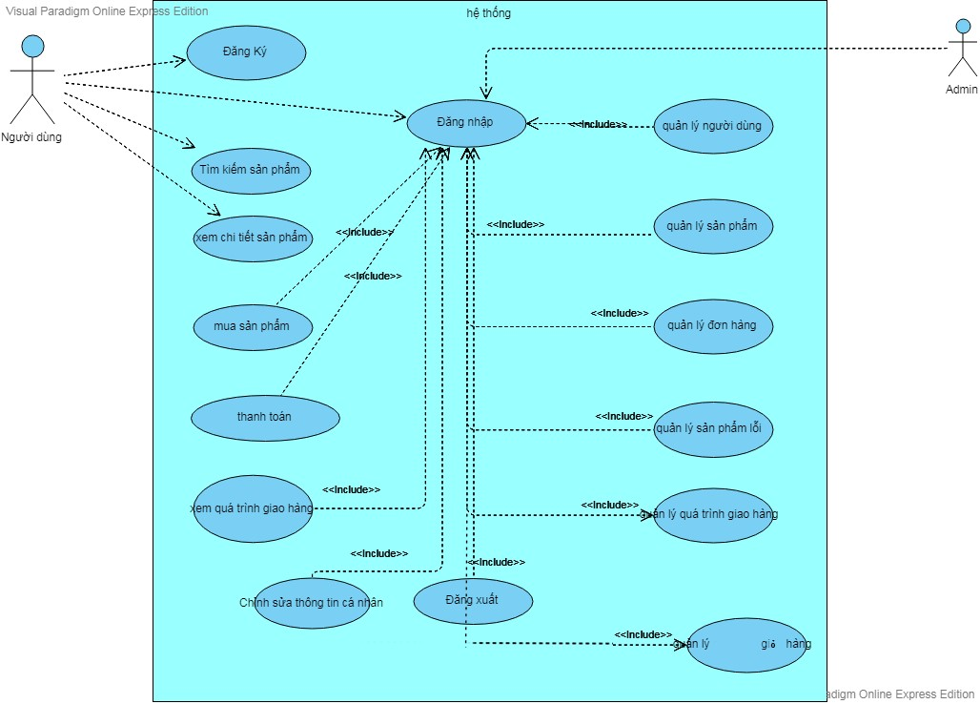

Figure 7.2 Use Case Diagram

## 7.3. Sequence Diagram

* Registration

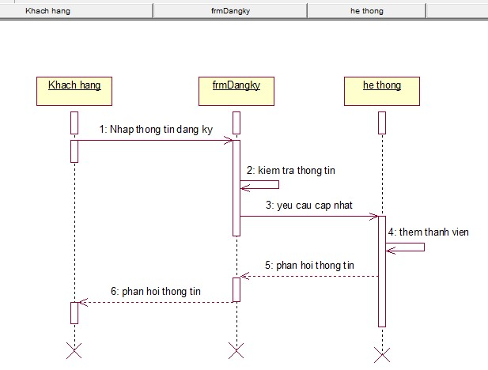

Figure 7.3 Registration

* Sign In

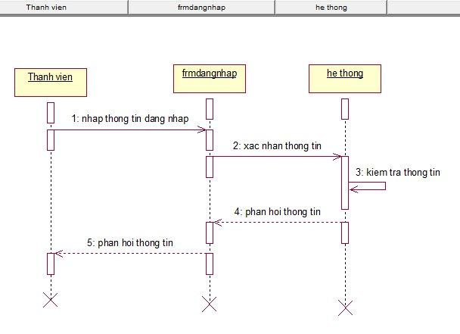

Figure 7.4 Sign In

* See Product

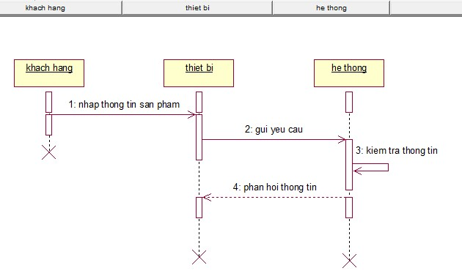

Figure 7.5 See Product

* Find Products



Figure 7.6 Find Products

* Purchase Of Products

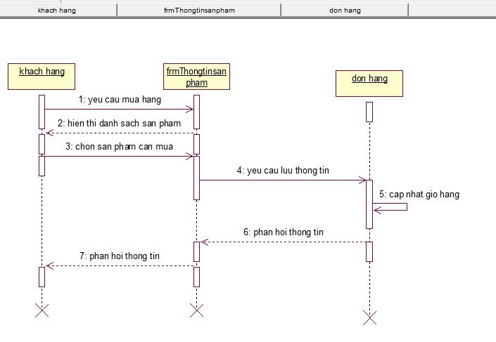

Figure 7.7 Purchase Of Products

* Payment

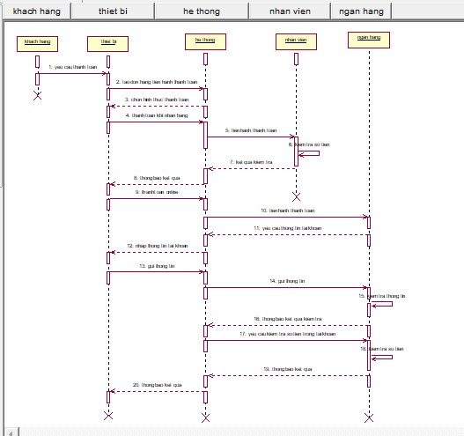

Figure 7.8 Payment

* View Delivery

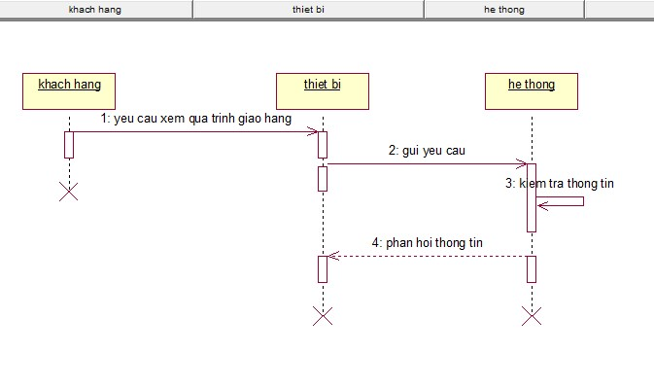

Figure 7.9 View Delivery

* Edit Personal Information

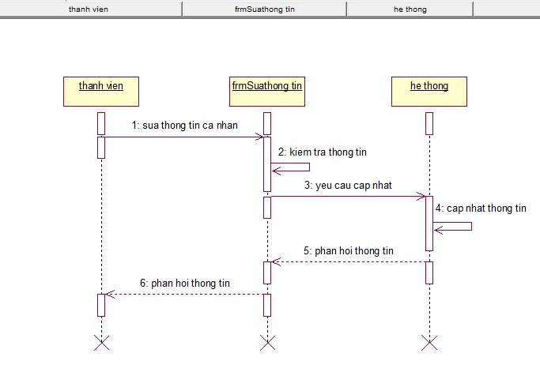

Figure 7.10 Edit Personal Information

* User Management

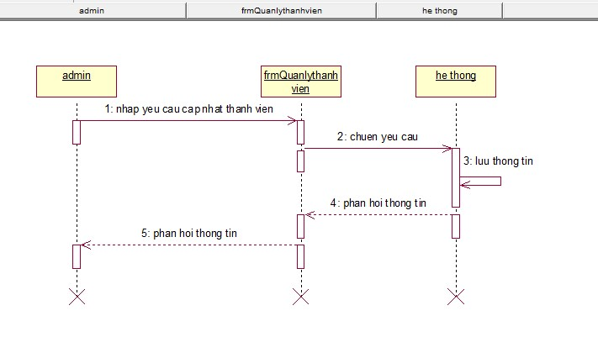

Figure 7.11 User Management

* Product Management

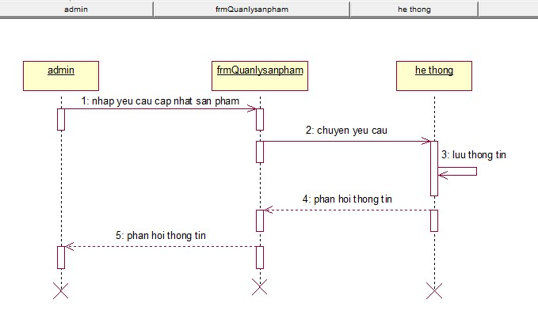

Figure 7.12 Product Management

* Order Management

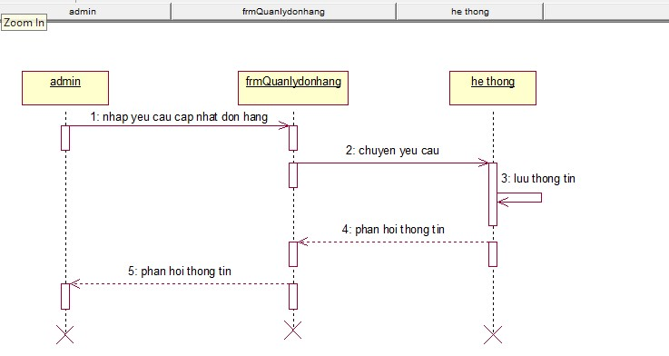

Figure 7.13 Order Management

* Fault Management

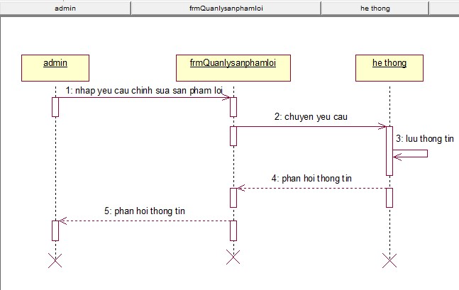

Figure 7.14 Fault Management

* Manage Delivery

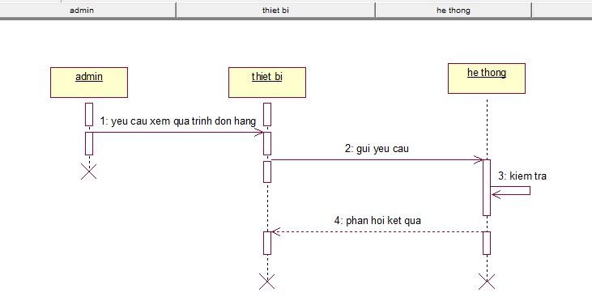

Figure 7.15 Manage Delivery

* Manage Cart

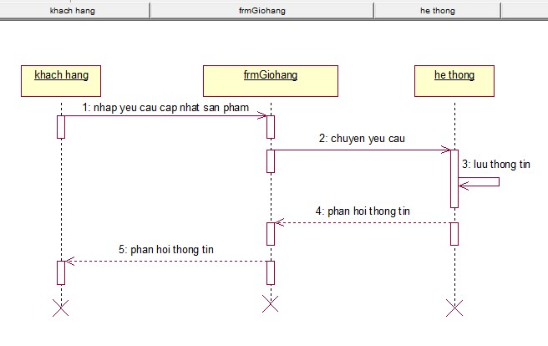

Figure 7.16 Manage Cart

8: Appendices

# 8. APPENDICES

## 8.1. Picture Catalog

Figure 2.1 Registration ................................................................................................... 5

Figure 2.2 Sign In ........................................................................................................... 6

Figure 2.3 See Product ................................................................................................... 6

Figure 2.4 Search For Products ...................................................................................... 7

Figure 2.5 Purchase Of Products ................................................................................... 7

Figure 2.6 View Cart ...................................................................................................... 8

Figure 2.7 Layout admin ................................................................................................ 8

Figure 4.1 Product Table .............................................................................................. 14

Figure 4.2 Account Table............................................................................................. 15

Figure 4.3 Manufacturer Table .................................................................................... 15

Figure 4.4 Payment Table ............................................................................................ 15

Figure 4.5 Cart Table ................................................................................................... 16

Figure 4.6 Delivery Schedule Table ............................................................................ 16

Figure 6.1 Home Page .................................................................................................. 19

Figure 6.2 Men's Watch ............................................................................................... 20

Figure 6.3 Women's Watches ...................................................................................... 20

Figure 6.4 Couple Watches .......................................................................................... 21

Figure 6.5 Product Information .................................................................................... 22

Figure 6.6 Manufacturer Information .......................................................................... 22

Figure 6.7 User Management ....................................................................................... 22

Figure 6.8 Product Management .................................................................................. 23

Figure 6.9 Product Information .................................................................................... 23

Figure 6.10 Cart Information ....................................................................................... 24

Figure 6.11 Manage Cart ............................................................................................. 24

Figure 6.12 Function block diagram choose and order ............................................... 25

Figure 6.13 Function block diagram payment ............................................................. 25

8: Appendices

Figure 6.14 Function block diagram register members ............................................... 26

Figure 6.15 Diagram of the search function block ...................................................... 26

Figure 7.1 Class Diagram............................................................................................. 27

Figure 7.2 Use Case Diagram ...................................................................................... 28

Figure 7.3 Registration ................................................................................................. 28

Figure 7.4 Sign In ......................................................................................................... 29

Figure 7.5 See Product ................................................................................................. 29

Figure 7.6 Find Products .............................................................................................. 30

Figure 7.7 Purchase Of Products ................................................................................. 30

Figure 7.8 Payment ...................................................................................................... 31

Figure 7.9 View Delivery............................................................................................. 31

Figure 7.10 Edit Personal Information ......................................................................... 32

Figure 7.11 User Management ..................................................................................... 32

Figure 7.12 Product Management ................................................................................ 33

Figure 7.13 Order Management ................................................................................... 33

Figure 7.14 Fault Management .................................................................................... 34

Figure 7.15 Manage Delivery ...................................................................................... 34

Figure 7.16 Manage Cart ............................................................................................. 35